|  |
| --- |
| **DEPARTMENT OF Computer Science & Engineering** |



**MENTORING BOOKLET**

|  |
| --- |
| **Course B.Tech.-CSE** |
| **Batch 2021-25** |

|  |
| --- |
| **Name: Nishant Kumar** |
| **Section: B** |
| **Admission ID: 2021B0101054** |
| **University Roll No.: 2100320100112** |
| **Aadhar No.: 513492470056** |
| **Mode of Admission : UPSEE** |
| **Accommodation : Day-scholar** |
| **Name of Mentor : Ms. Prabhjot Kaur** |
|  |

|  |
| --- |
| **ABES Engineering College**  **19th Km Stone, NH-24, Ghaziabad – 201009 (UP), INDIA**  **Ph: 0120-7135112, Fax : 0120-713511mail:** [**info@abes.ac.in**](mailto:info@abes.ac.in)**.website:**[**www.abes.ac.in**](http://www.abes.ac.in/) |

**Personal Details of the Mentee**



University Roll No: 2100320100112

Correspondence Address: G- 549, Govindpuram, Ghaziabad, Uttarpradesh

Permanent Address: G- 549, Govindpuram, Ghaziabad, Uttarpradesh

Mobile No. (Student’s): 8882833467

Student’s Photograph

Mobile No. (Father): 9711072123

Mobile No. (Mother): 9718782906

Email (Student’s): nishant543099@gmail.com

Email (Parent’s): cdsgzb@gmail.com

Occupation of Father: Business

Academic Qualifications

|  |  |  |  |
| --- | --- | --- | --- |
| Class | Board/University | Percentage (Aggr.) | Percentage (PCM/PCB/SCIENCE) |
| 10th | CBSE | 77% | 83% |
| 12th | CBSE | 89.6% | 84.66% |
| other | NA | NA | NA |

Participation in Co/Extra-Curricular Activities (during course)

**Assessment during 1st Semester**

**Mentor’s Name: Ms. Prabhjot Kaur (Associate Professor-CSE)**

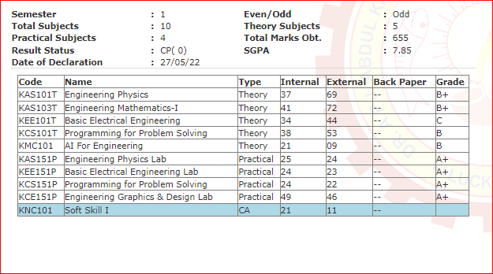

**Remarks by mentor (Excellent, V.Good, Good and Poor)**

|  |
| --- |
|  |
|  |

**Mentor Signature**

**Assessment during 2nd Semester**

**Mentor’s Name: Ms. Prabhjot Kaur (Associate Professor-CSE)**

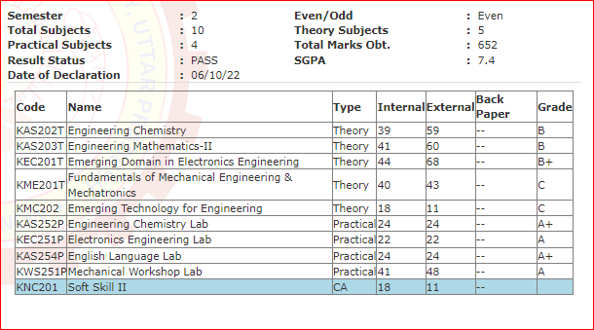

**Remarks by mentor (Excellent, V.Good, Good and Poor)**

|  |
| --- |
|  |
|  |

**Mentor Signature :**

**Assessment during 3rd Semester**

**Mentor’s Name: Ms. Prabhjot Kaur (Associate Professor-CSE)**

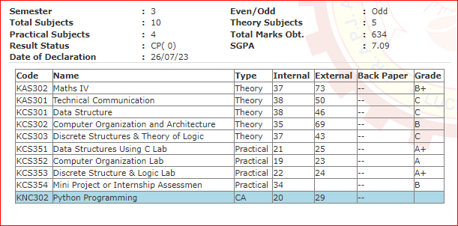

**Remarks by mentor (Excellent, V.Good, Good and Poor)**

|  |
| --- |
|  |
|  |

**Mentor Signature :**

**Assessment during 4rd Semester**

**Mentor’s Name: Ms. Prabhjot Kaur (Associate Professor-CSE)**

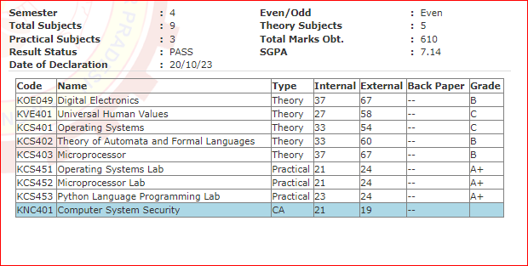

**Remarks by mentor (Excellent, V.Good, Good and Poor)**

|  |
| --- |
|  |
|  |

**Mentor Signature :**

|  |  |  |  |  |  |  |  |  |  |  |
| --- | --- | --- | --- | --- | --- | --- | --- | --- | --- | --- |
| **Trainings for Skill Building and Certifications** | | | | | | | | | | |
| **S.No.** | **Title of Training** | | | | **Discipline** | | | **Place** | | **Duration** |
| 1. | [100 Days of Code: The Complete Python Pro Bootcamp for 2023](https://e2.udemymail.com/ls/click?upn=ZF3sOyS2SxEPIoSZT6Aoc-2BEAPso9xRA49IDbkpAnXimM-2BOKFVML7jAvFCPmbO05TxfVCqq-2FrZYRDU82SovSbFhYh7y7e8ZxHCROn5csuLX7-2F5VHa3kYC5HQEHM-2FG7zQTJmxKdeZgCVa6zGozngMshA-3D-3Dwzmd_RHtS5JV1B00w5oTSXwn09vRJXcQdAy-2Bnl-2FTGECrw1KwZGek28Y0Mmb3pyQRwuthbg0Hl-2FBflVmvxdH0EuIv63I-2FpK4-2BjYuPJ33TBiXp3LLjo0RdBrS3hlRtkvRGCgopy3RfjRalIt39zUa6BApsbNrUOCPmmOXqqF5Lhg4TJhnD5UY0EvllFgH5M8cV-2FgoSrR2POlwS-2Ff7NSpb7W-2Bh0efIXrhQCokuWfEL6WyjA97ZMp1lT6FKi0hGVwQTIK5iaczKOzP6qYhUn0n1ovDnEOOEBOxj8jexFfe3kdd9-2BgZHJnis-2FSK3z-2B1Hw2VQnMj42alS1UNzvjdFLEDt7TEQkoVQZQGI9GV9SRTIBXyh08fVA-3D) | | | |  | | | online | | 59 hrs |
| 2. | Essentials of cloud computing | | | |  | | | online | | Self paced |
| 3. | Problem Solving (Basic) | | | |  | | | online | | 1.5hr |
| 4 | Microsoft azure Ai fundamentals | | | |  | | | online | | 1.5 hr |
| **Industrial Training** | | | | | | | | | | |
| **Company Name** | | **Company Sector** | | **Incorporation Status** | | **Discipline** | | | **Date From** | **Date To** |
| NA | | NA | | NA | | NA | | | NA | NA |
| **Project** | | | | | | | | | | |
| **Title of Project** | | | **Duration** | | | | **Supervisor Name** | | | |
| **HR Analysis and Management System** | | | **4 Month** | | | | **Dr. Meeta chaudhary** | | | |
| **Student Dropout Analysis for school education** | | |  | | | | **Ms. Prabhjot Kaur** | | | |



